**Netcompany – Methodology and Security**

**A0150 - User-Interface Prototype**

.

.

.

.

.

.

.

.

.

.

.

.

.

.

.

.

|  |  |
| --- | --- |
| **Version:** | **2.1** |
| **Status:** | Approved |
| **Approver:** | Leni Støvring Barfred |
| **Author:** | Casper Slynge |



**Document history**

|  |  |  |  |  |
| --- | --- | --- | --- | --- |
| Version | Date | Author | Status | Remarks |
| 1.0 | 18-09-2015 | Leni Barfred | Final |  |
| 2.0 | 04-05-2016 | Simon Shan Man Ng | Approved | 2016 New logo |
| 2.1 | 24-09-2020 | Casper Slynge | Approved | Tools section expanded |

**References**

|  |  |  |  |
| --- | --- | --- | --- |
| Reference | Title | Author | Version |
|  |  |  |  |

Table of contents

1 Introduction 3

1.1 Purpose 3

1.2 Target group 3

1.3 Reference group 3

2 Guideline to A0150 3

3 Tools 4

3.1 Drawn mockups 4

3.2 Adobe XD 4

3.3 Invision Studio 5

3.4 Axure 5

3.5 Marvel App (https://marvelapp.com/) 7

3.6 Balsamiq (https://balsamiq.cloud/) 10

# Introduction

## Purpose

Using a prototype to test a design and validate it with others is invaluable for making better design decisions. The purpose of the deliverable is to provide the customer with an initial impression of the functionality of the future solution in the form of either a hardcopy prototype or an electronic prototype for parts of the solution, including the visual expression.

## Target group

The target group for this deliverable is made up of the customer's personnel who are responsible for user-friendliness and the user interface.

## Reference group

It is important to involve Netcompany's User Interface consultants to ensure that we do not design an interface that is difficult to implement.

# Guideline to A0150

The prototype is a way of visualizing the rough outlines of the future solution and may cover the following elements:

* System functionality (how are functions activated in the system?)
* Division of significant page types
* Look & Feel (if graphic design is present and decided upon)
* Rough outline for information architecture
* Proposal for primary navigation
* Positioning of key elements (search, tools, help, etc.)

The above elements can be visualized by simply involving rough outlines/mockups put together using copy/paste from previous Netcompany solutions, competing sites and any existing solution the customer may have. The copy/paste option works well in Axure, Word or PowerPoint when producing the first prototype during the analysis phase. The prototype can also be developed from scratch by using one of the many tools described in section 3

System functionality will be detailed later in *D0160 - User-Interface Design*.

The contents of the prototype are agreed with the customer so that there is agreement on which parts of the solution that will be modelled in rough outlines.

When preparing the deliverable, the elements to be used later in the user interface must generally be considered closely. *D0100 - User-Interface Guidelines* includes a list of elements to be assessed as early as the preparation of the prototype.

When the deliverable is prepared by a third-party supplier, it is important

1. for Netcompany User Interface consultants to review the material and make sure that the prototype can be implemented later. The remarks of the Netcompany User Interface consultants must be incorporated in the deliverable before presenting this to the customer so that expectations can be managed
2. in the case of SharePoint solutions, for Netcompany User Interface to hold a half-day workshop with the design supplier at which the SharePoint platform and its limitations/challenges are presented

# Tools

The format of this deliverable may vary. Typically, the deliverable is prepared in Axure and exported to Microsoft Word but a variety of tools may be used.

## Drawn mockups

If no design or guidelines have been decided upon, the prototype may consist of drawn mockups. This can help in the very early stages of a project during workshops with the customer. The mockups can be a great tool to ensure that Netcompany and the customer are on the same page regarding the essential user interface elements of the solution.

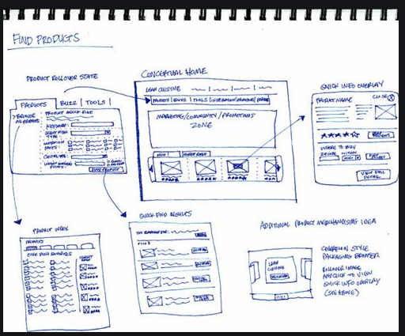

Figure 1: Drawn mockups can be a great way of getting an overview of different views in a solution

## Adobe XD

Adobe XD is a relatively new prototype tool released by Adobe. It is a vector based user interface design tool for both web apps and mobile apps. It allows the user to create prototypes with animations and states to include interactions like in a real solution.

The Adobe XD prototype can be previewed on desktop and mobile devices. Responsive resize is a feature in Adobe XD which automatically adjusts and sizes pictures and other objects on the artboards. This allows the user to have their content automatically adjusted for different screens for different sized platforms.

Another great feature of Adobe XD, is that it supports and can open files from Illustrator, Photoshop, After Effects and other Adobe products. It is easy for projects to collaborate together on the prototype by using the Creative Cloud for Microsoft Teams (<https://www.adobe.com/creativecloud/integrations/creative-cloud-microsoft-teams.html>). Plugins can also be added for additional features and uses. The plugins range from design to functionality, automation and animation.

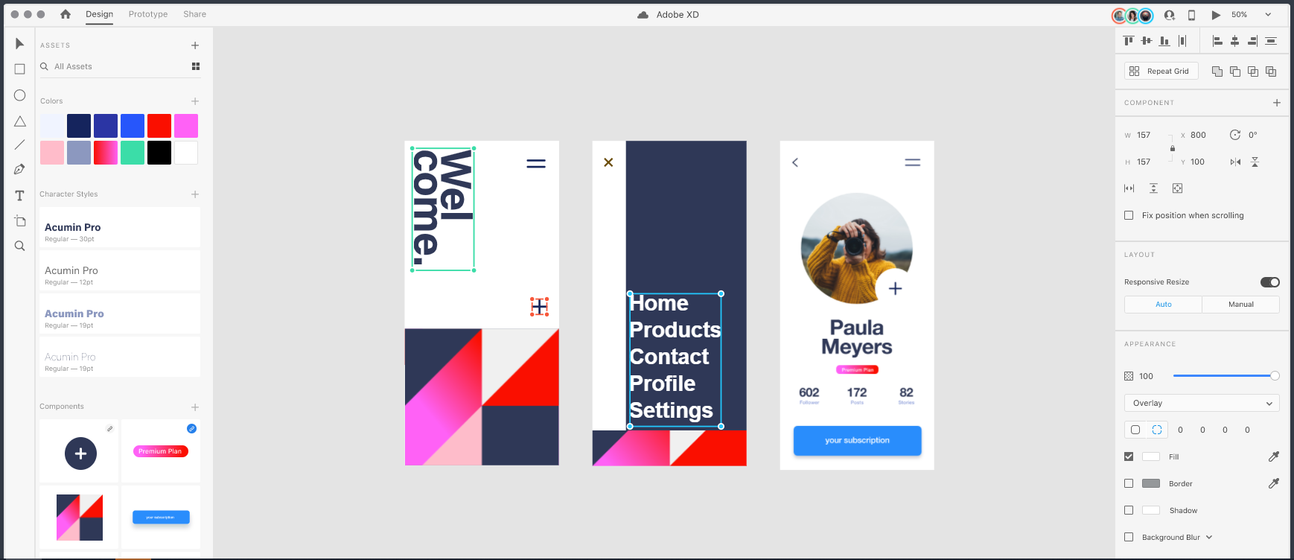

Figure 2: Adobe XD lets the user quickly set up different views and create states between them

## Invision Studio

Invision Studio is similar to Adobe XD. It offers its own vector based design editor where the user can create prototypes with animations and micro-interactions. Teams can collaborate directly inside the prototype to notify about changes and add feedback, and just like Adobe XD it also integrates easily with Microsoft Teams, Slack, etc.

The focus of Invision Studio is to have everything related to the prototype managed in one single place. So besides having its own chat feature, files like icons and images can also be shared and stored inside Invision Studio. When the prototype is ready for development, the inspector feature allows the user to copy styling properties of all elements.

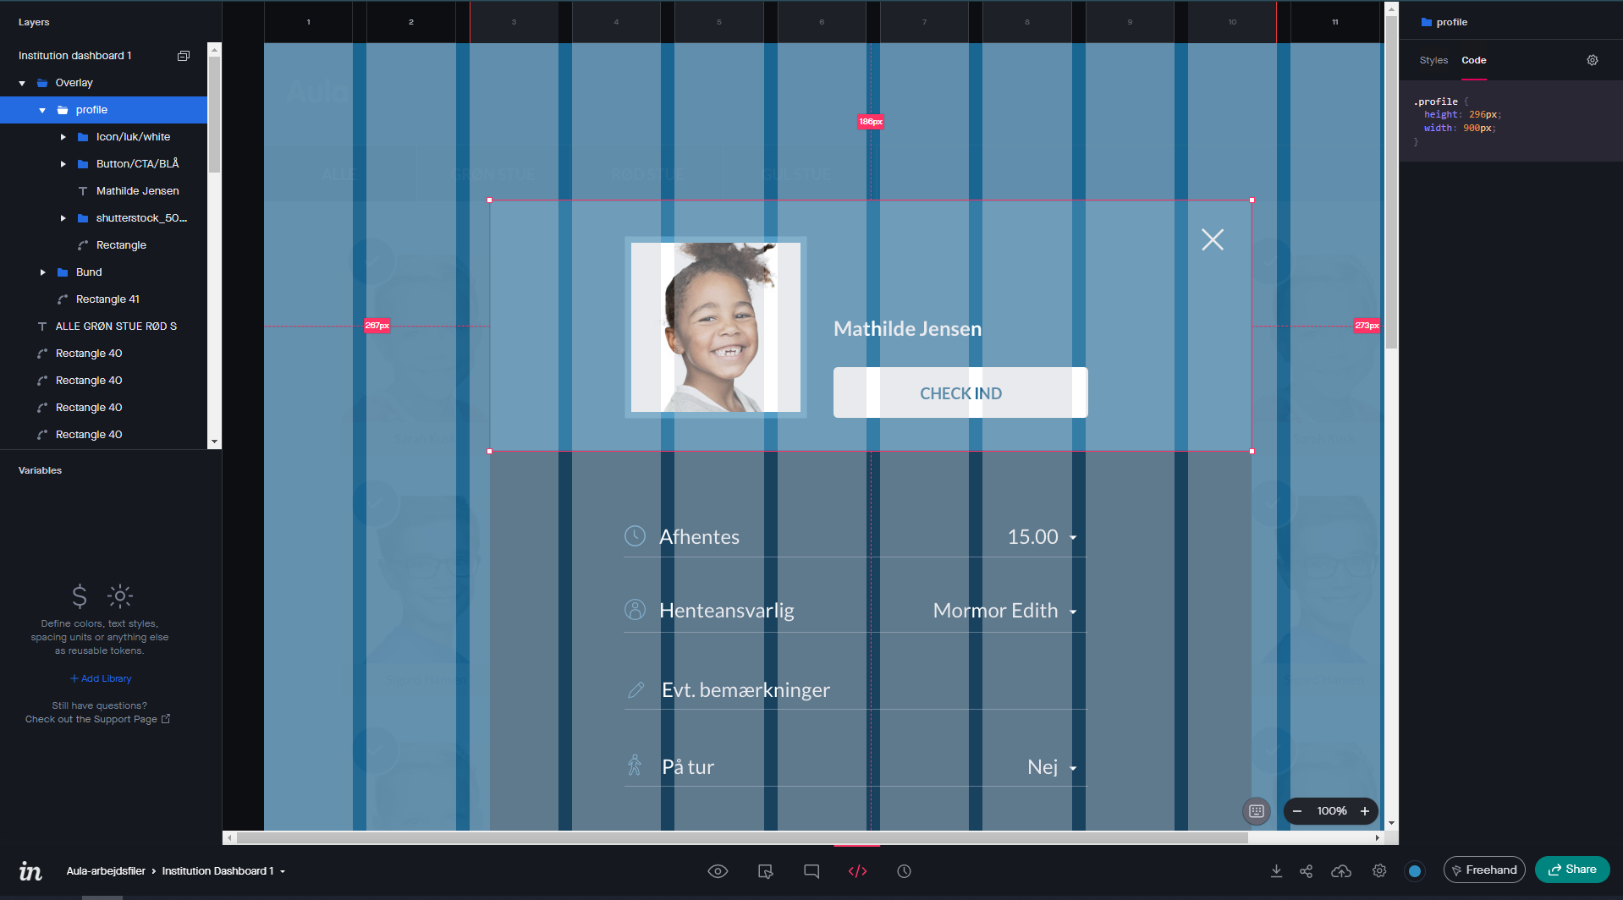

Figure 3: Styling properties can be viewed directly in Invision Studio inspector mode

## Axure

As mentioned, Axure is probably the tool that is most used for creating prototypes in Netcompany. Axure lets you quickly make rich, functional prototypes where it is possible to test almost everything. This is possible because it allows the user to create code-like interactions in order to make the prototype look and act like a real solution.

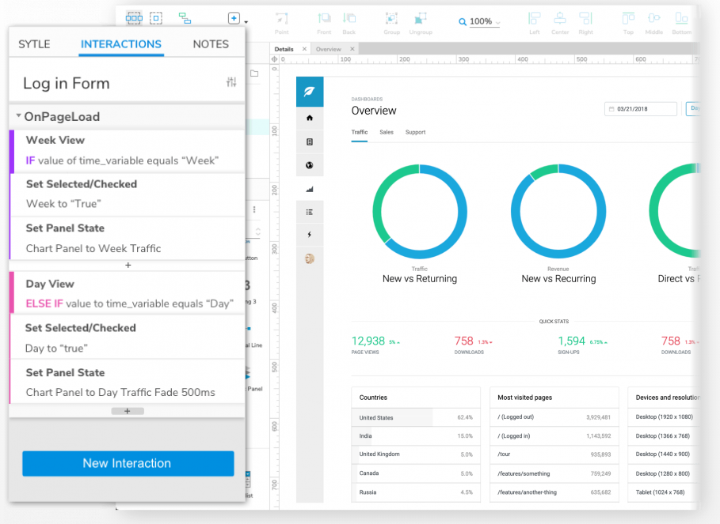

Figure 4: Axure allows the user to set up interactions with the prototype

Axure combines powerful design tools, SVG import, and Sketch, Figma, and Adobe XD integrations. So it is easy to integrate with other prototype tools. Moreover, it is easy to convert the prototype to actual development. The elements in a prototype are created with specifications that are well-known to developers, making it possible to export CSS code directly from Axure, to use in development. Finally, the solution can also be published directly into HTML pages.

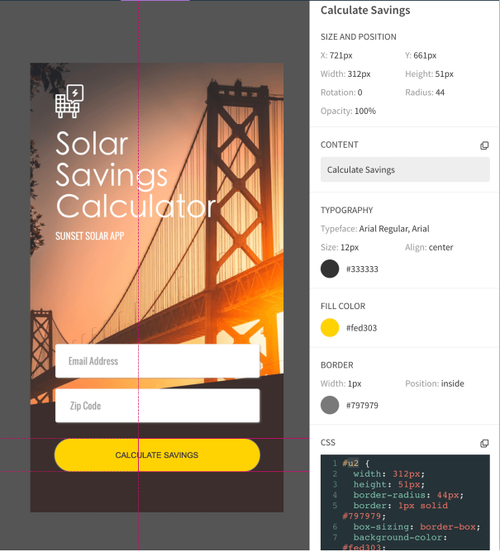

Figure 5: CSS code can be copied directly from Axure elements

## Marvel App (<https://marvelapp.com/>)

Marvel is a web-based wireframe and prototype tool, which offers a great deal of options[1] for prototyping, testing, review and collaboration. It is especially good for fast prototyping and demonstrating the interaction flow. To start, create (Figure 6 - 1) or open (Figure 6 - 2) an existing project:

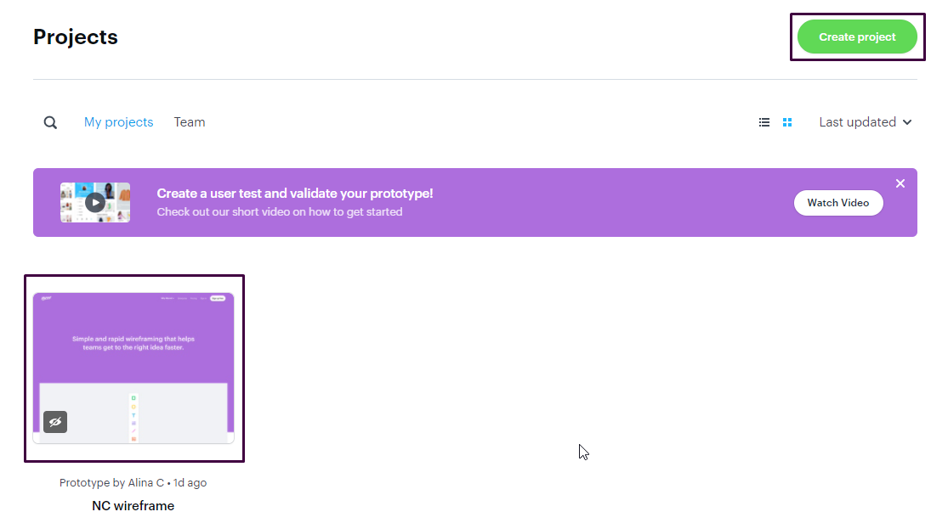

Figure 6: Marvel app

Inside the project, access the project settings (Figure 7 - 1) to set the desired device type and orientation (Figure 7 - 2) for your wireframe:



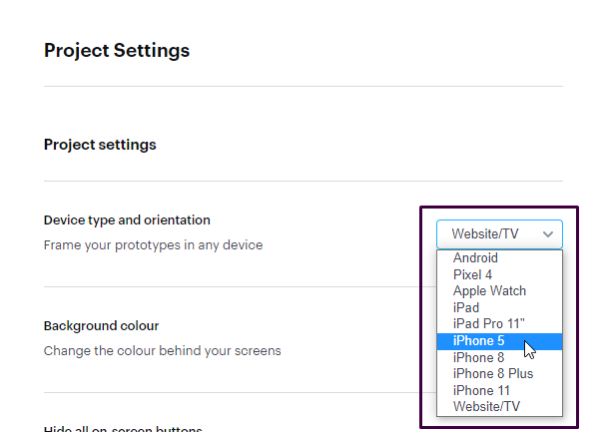

Figure 7: Marvel app

From the project settings, you can also control other options such as backgorund color, prototype interaction settings, etc.

If the application you are working on already has application screens designed by a third party, you can upload them (Figure 8 - 1). Alternatively, you can start designin (Figure 8 - 2):

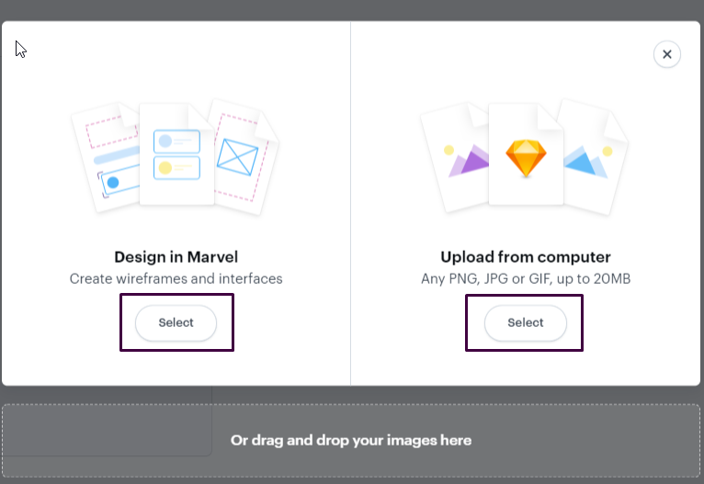

Figure 8: Marvel app

When you have entered design mode, start designing your wireframe. You can use shapes, lines and images[2] or Marvel’s gallery og predefined elements (Figure 9 - 1). Choose the platform you are working on (Figure 9 - 2) and use the predefined screens and elements to create your wireframe.

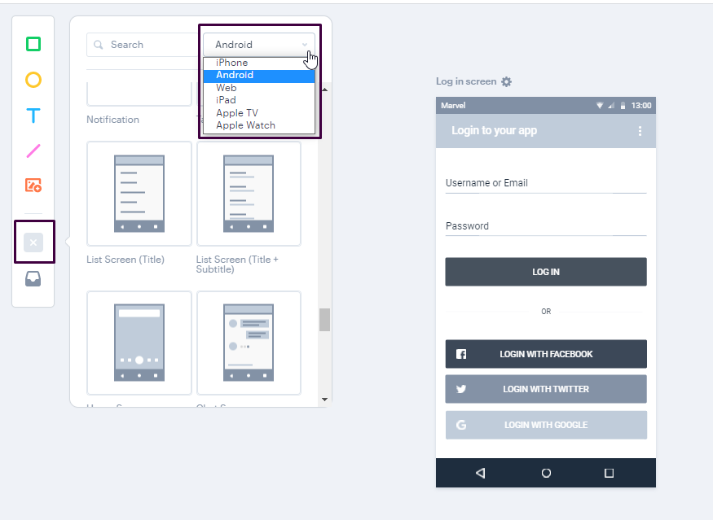

Figure 9: Marvel app

If the client has a CVI / visuals that should be used you can upload (Figure 10 - 2) the elements as png, jpeg or gif in the image tab (Figure 10 - 1):

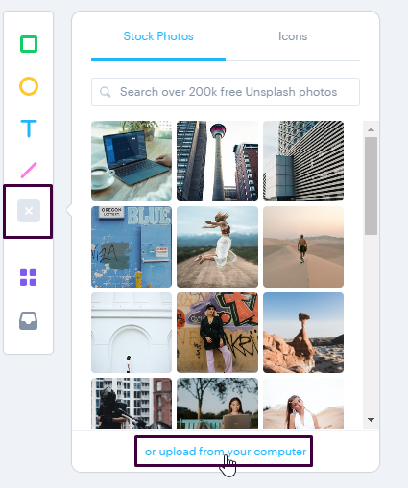

Figure 10: Marvel app

When your wireframe is ready, you can define the interaction in the prototype mode:

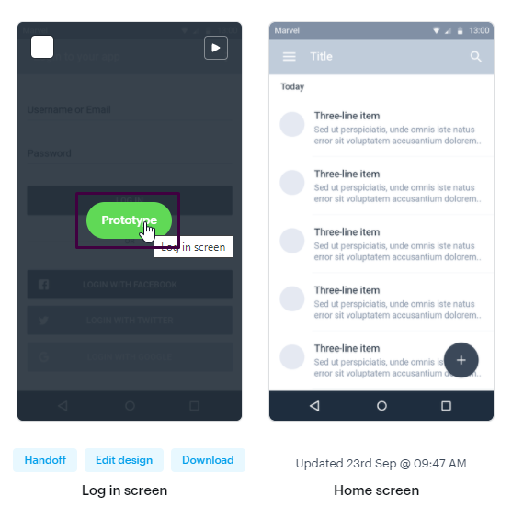

Figure 11: Marvel app

Define a hotspot area (what the user can click) (Figure 12 - 1) and define the destination, screen transition, action that should be triggered upon clicking the hotspot area.

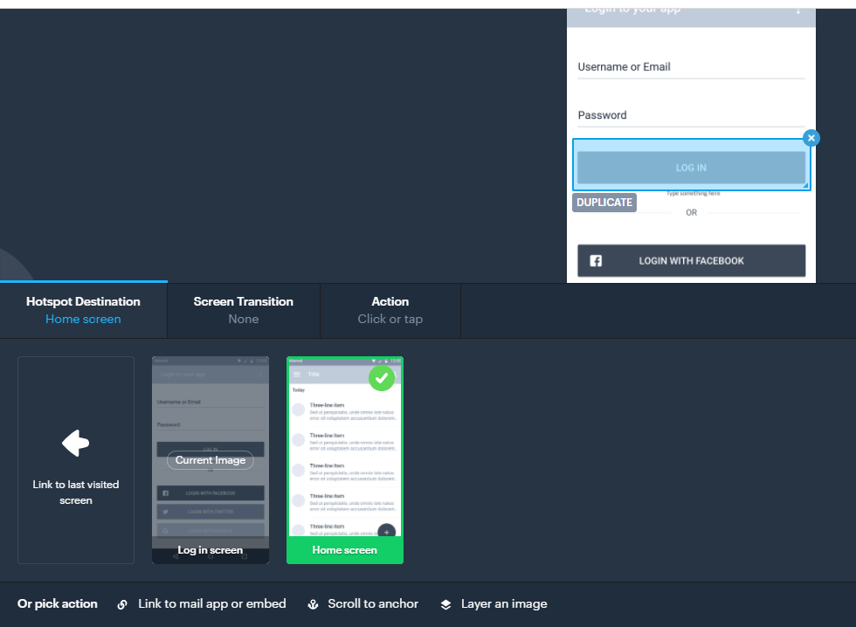

Figure 12: Marvel app

When ready, play the prototype and verify the interaction flow is as expected. You can share prototype with the client / team for review. If you wish to perform a more structured review of the prototype, Marvell has a feature that allows one to record the screen and camera of the user testing the prototype and can be accessed from the project main screen:



Figure 13: Marvel app

You can find more information about user testing with Marvel here: <https://help.marvelapp.com/hc/en-us/articles/360002558237>.

## Balsamiq (<https://balsamiq.cloud/>)

Balsamiq is a rapid low fidelity wireframing tool, useful for solution sketching, without any detailed visuals. It is recommended for a fast design process, to align with the client on functionality, structure and content of the solution to be delivered. Its interface is straightforward. One can use predefined controls /UI elements (Figure 14 - 1) to create screens or download complete projects and templates from More Controls (Figure 14 - 2).

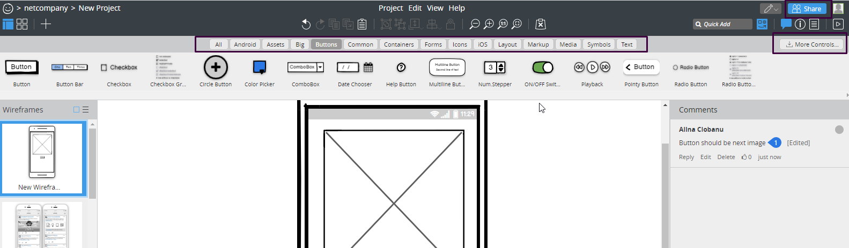

Figure 14: Balsamiq

The UI elements come in two variants Sketch and Wireframe (Figure 15 - 2). This can be adjusted by accessing the Project information menu (Figure 15 - 1). Other options such as link color and font can be adjusted here.

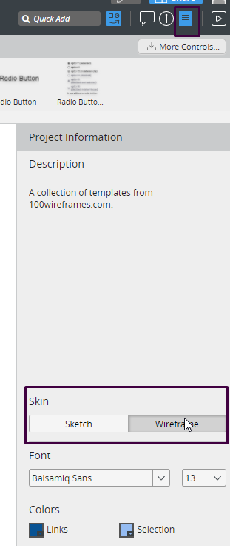

Figure 15: Balsamiq

The wireframe prototype can be exported as PDF/PNG or shared for on platform review by the project stakeholders (Figure 16 - 2):

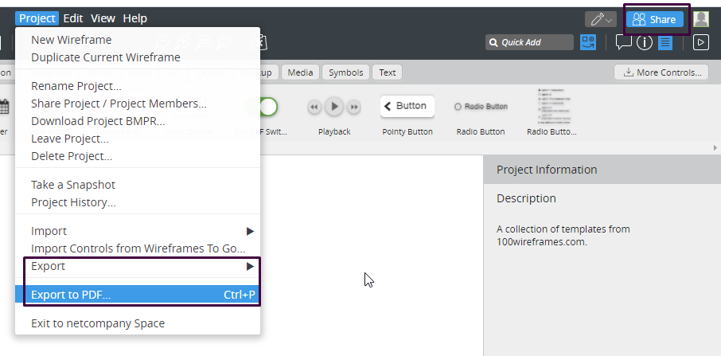

Figure 16: Balsamiq

TIP: Make sure to inform the client, that the wireframe is not an exact representation of what the application will look like and that the purpose of the prototype is to align on expectation for the overall design and functionality and not on the final aesthetics of the application. These may often depend on the implementation platform, corporate visual identity etc.

1. Some features may be only available paid plans, see [pricing](https://marvelapp.com/pricing) for an overview.
2. TIP: You should however be extra careful with using images in the wireframing stage, unless you have a clear requirement to do so. This will draw the attention from the overall design and interaction flow and create redundant back and forth feedback with the client on the specific image used.